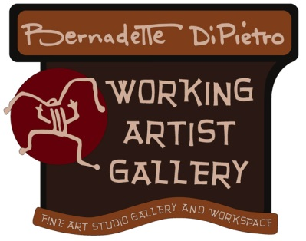

**WORKING ARTIST GALLERY**

**109 NORTH BLANCHE STREET**

**SUITE 103**

**OJAI, CA 93023**

**805-646-2539**

Thank you for your interest in renting the studio for a meeting, a gathering or offering an art workshop at Working ARTIST Gallery, a shared fine art studio, work space for artists and teachers. The Gallery recommends that each artist teaching a workshop promotes their class with posters, mail, e-mail, and forwarding the monthly newsletter to potential participants. Please contact Bernadette regarding rental fees for the gallery/studio.

**Working ARTIST Gallery will:**

* Promote your art workshop at no charge in the newsletter that is sent out via e-mail to over 1,100 contacts each month
* Offers liability insurance and pays all utilities, including heating and air-conditioning
* The use of two large rest rooms, free parking, the use of tables and chairs with excellent lighting
* Will offer to the artist/renter 5% of any sale that takes place while the artist/renter is teaching a workshop, and they collect the full price of a clearly marked item that includes sales tax

**The Artist or Renter (for a meeting or gathering) will:**

* Agrees to take full responsibility for any loss or damage, including any missing books, art materials, and art work.
* Agrees to leave the studio space as they found it before their workshop, including vacuuming (if necessary) locking doors, turning off heat and air conditioning and emptying trash
* Agrees to pay full rental for the gallery/studio at the beginning of each workshop
* Agrees to pay the full rental fee at the beginning of an ongoing session that meets more than once
* Agrees to return keys immediately after each workshop
* Agrees to keep brown carpeting free of paint or stains and will pay the cost of re-carpeting if necessary
* Agrees not to use any of the art supplies owned by the gallery unless previous arrangements have been made in writing
* Agrees to graciously welcome any customers who may stop by during their workshop and requests the customer to sign the mailing list for future workshops OR can also have the option to keep the studio closed to possible customers
* Agrees to contact Bernadette if a customer has an interest in purchasing an item
* The artist/teacher will supply: Information for an upcoming class by the 15th of the previous month for the newsletter that would include:

1. Photograph/image as a J-peg (not on a word Document)
2. Class Name
3. Hours of class
4. Date of class
5. Price for the class
6. Short description of the class
7. Registration information for the class with e-mail and phone number
8. A few sentences about the artist